# **Biography**

*For fans of: Volbeat, D:A:D, Nickelback, Shinedown, Black Label Society*

Emerging from Esbjerg, Denmark in 2016, Black Oak County is a dynamic force in the world of hard rock and metal. Formerly known as Great White Buffalo, the band has developed a signature sound that fuses classic rock influences from the 70s and 80s with elements of sludge, grunge, modern hard rock, and contemporary metal. This unique blend has become their hallmark.

The quartet, consisting of Niels Beier (vocals/guitar), René Kristensen (vocals/bass), Jack Svendsen (guitar), and Mike Svendsen (drums), united to chase a shared musical vision, one that would ultimately propel them to the grandest stages in the rock scene.

Black Oak County made waves with their self-titled sophomore album in 2016, featuring standout tracks like *Mad Dog*, *Someone Else*, and the emotive ballad *If You Only Knew*. Their evolution took an intriguing turn when Niels Beier briefly parted ways with the band, leading to their 2019 release of *Theater of the Mind* as a power-trio. This album introduced heavy-hitting tracks like *Pretty Pistol* and the monumental *Watch Your Back*, arguably the band’s biggest song to date!.

In 2022 the band's reunion with Beier brought them back to their original four-piece lineup. This marked the release of *Back For Blood*, an explosive return to form, securing them a nomination for *Single of the Year* at the Danish hard rock and heavy metal award show Den Hårde Tone. The band followed up with *It's On You*, a single co-written with renowned guitarist, producer, and songwriter Soren Andersen (*Glenn Hughes, Mike Tramp, Marco Mendoza*), and produced, engineered, mixed, and mastered by Grammy-nominated producer Jacob Hansen (*Volbeat, Arch Enemy, Invocator*) of Hansen Studios.

Black Oak County's live performances are nothing short of electrifying, having shared the stage with rock legends such as The Dead Daisies and D:A:D. Their diverse discography and unwavering passion have earned them a well-deserved place among the rock warriors of their generation.

With their powerful sound and relentless determination, Black Oak County continues to make their mark on the global rock stage. Their music resonates with a blend of nostalgia and contemporary energy, establishing them as a potent force in the world of rock and metal.

The band’s thirds studio album *III*, co-written, produced, engineered, mixed and mastered by Nicklas Sonne (*Defecto, Eurovision Song Contest preliminaries*), is out worldwide on October 25th. For tour dates and more, visit [www.blackoakcounty.com](http://www.blackoakcounty.com).

**Links**

### **Spotify**

[Black Oak County | Spotify](https://open.spotify.com/artist/5W3Q0PiFwL9CCPJ6YDDibK?si=96fa48c2dad84b11)

[Official Spotify Playlist - This Is Black Oak County](https://open.spotify.com/playlist/37i9dQZF1DZ06evO3uZhtv?si=7593d38a4e034236)

### **Check out our very own playlist!**

[Essential - Black Oak County - playlist by Niels Vinbech Beier | Spotify](https://open.spotify.com/playlist/6sJsKZAHNShOCSphkuW0Eu?si=218ce59f86cc4574)

### 

### **Music videos**

[Black Oak County - Save Your Breath (Official Music Video)](https://www.youtube.com/watch?v=9CVClM0SYUo&ab_channel=MightyMusic)

[Black Oak County - Save Your Breath (Official Music Video)](https://www.youtube.com/watch?v=TrG1Z87dOn0&ab_channel=MightyMusic)

[Black Oak County - Back For Blood (Official Music Video)](https://www.youtube.com/watch?v=ztHecMDC-vM&ab_channel=MightyMusic)

[Black Oak County - It's On You (Music Video)](https://www.youtube.com/watch?v=mzMmc-5R704&ab_channel=MightyMusic)

[Black Oak County - If You Only Knew (Official Music Video)](https://www.youtube.com/watch?v=YKiNA-NHawI&ab_channel=MightyMusic)

[Black Oak County - Pretty Pistol (Official Music Video)](https://www.youtube.com/watch?v=jMcKcL2_vtw&ab_channel=MightyMusic)

[Black Oak County - Someone Else (Official Music Video)](https://www.youtube.com/watch?v=gA99SArDtB4&ab_channel=MightyMusic)

[Black Oak County - It's On You (Music Video)](https://www.youtube.com/watch?v=mzMmc-5R704&ab_channel=MightyMusic)

[Black Oak County - Wasted Life (Official Music Video)](https://www.youtube.com/watch?v=0VwVMY0_bGI&ab_channel=MightyMusic)

[Black Oak County - Mad Dog (Official Music Video)](https://www.youtube.com/watch?v=AQwSgFRVbx4&ab_channel=MightyMusic)

### **Social Media**

**Facebook:**

[www.facebook.com/BlackOakCounty](http://www.facebook.com/BlackOakCounty)

**Instagram:**

[www.instagram.com/blackoakcounty](http://www.instagram.com/blackoakcounty)

**Website:**

[www.blackoakcounty.com](http://www.blackoakcounty.com)

# **Streaming statistics**

### **Spotify streams & more** *(updated August 17th, 2024. Numbers from Spotify for Artist)*

**Spotify streams:** 8.500.000+

**Streams (past 12 months):** 3.600.000 (August 2023 - August 2024)

**Total Spotify audience:** 660.000+ (worldwide)

**Monthly listeners:** 60 - 80.000

**Spotify followers:** 10.000+

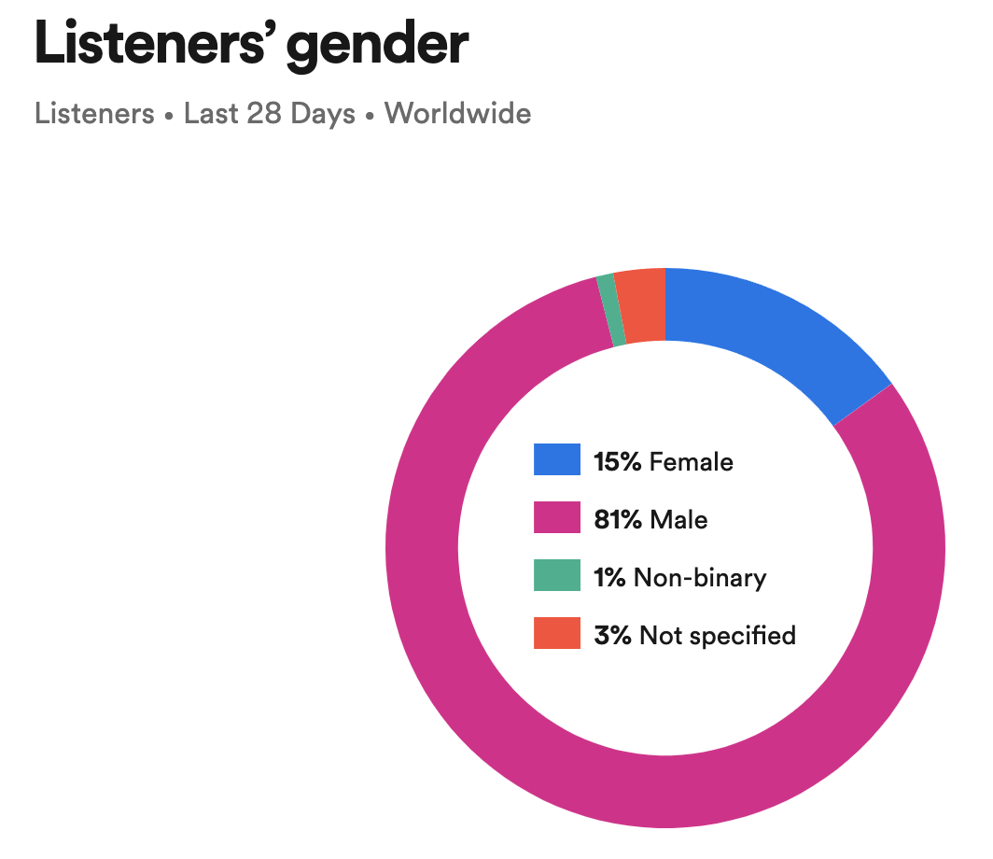

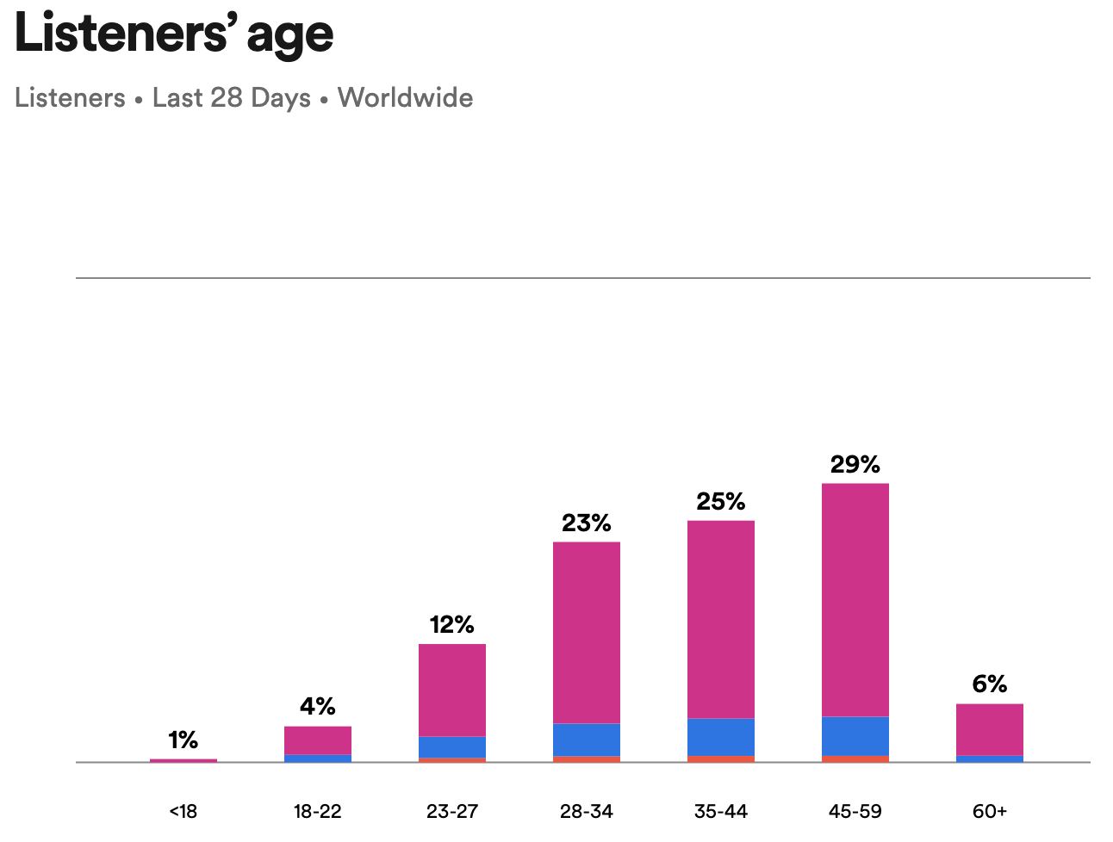

Spotify Wrapped (Januar, 2023)

